Recommendation Letter for Padma Shri Award 2027
To,
The Padma Awards Committee
Government of India
Subject: Recommendation for Conferment of the Padma Shri upon Dr. Umar Alisha
Respected Members of the Padma Awards Committee,
It is with great respect that I submit this recommendation in support of Dr. Umar Alisha, the 9th Peethadhipathi of Sri Viswa Viznana Vidya Adhyatmika Peetham, for the conferment of the Padma Shri Award 2027.
Dr. Umar Alisha’s life and work represent an exceptional combination of spiritual leadership, humanitarian service, institution building, and sustained public welfare extending over more than three decades. As the spiritual head of Sri Viswa Viznana Vidya Adhyatmika Peetham, he has preserved and strengthened a rich spiritual tradition while making its teachings relevant to contemporary society through values of compassion, peace, ethical living, and service to humanity.
His guiding philosophy of “Service to Humanity is Service to God” is reflected not only through spiritual discourses and teachings but also through practical initiatives benefiting people from all sections of society, irrespective of religion, caste, language, gender, or economic background.
Under his leadership, Sri Viswa Viznana Vidya Adhyatmika Peetham has expanded its spiritual outreach through discourses, publications, meditation programmes, value-based education, and initiatives promoting moral and social responsibility. He has inspired volunteers and followers to transform spiritual principles into meaningful service activities that promote compassion, social harmony, and community welfare.
As the Founder-Chairman of Umar Alisha Rural Development Trust (UARDT), Dr. Umar Alisha has guided numerous initiatives in rural development, healthcare, education, environmental conservation, plantation activities, women empowerment, youth development, disaster relief, and humanitarian service. Through medical camps, blood donation drives, educational support, environmental awareness programmes, tree plantation activities, and relief initiatives, the Trust has contributed to improving the lives of communities and encouraging sustained volunteer participation.
The uniqueness of Dr. Umar Alisha’s contribution lies in his ability to integrate spirituality with practical social impact. His work demonstrates how spiritual institutions can actively contribute to nation-building by addressing social needs, promoting environmental responsibility, and encouraging inclusive development.
He has also promoted universal human values, interfaith harmony, ethical leadership, and peaceful coexistence through his teachings, writings, and public engagement. His message of compassion and selfless service continues to inspire individuals in India and abroad to contribute positively to society.
The enduring impact of Dr. Umar Alisha’s work is reflected not only in his personal achievements but also in the institutions he has strengthened, the volunteers he has inspired, and the communities that continue to benefit from his vision and service-oriented initiatives.
The Padma Awards recognize distinguished service of the highest order. Dr. Umar Alisha’s lifelong dedication to spirituality, humanitarian service, environmental conservation, education, healthcare, rural development, and social harmony embodies the values and spirit of this prestigious civilian honour.
In view of his sustained contributions, exemplary leadership, and lasting impact on society, I respectfully recommend Dr. Umar Alisha for the Padma Shri Award 2027. His life and work represent the ideals of compassion, integrity, service, and nation-building that this honour seeks to recognize.
Sincerely,
Relationship with Nominee: Disciple and follower of Dr. Umar Alisha’s spiritual teachings and social service activities
Contact Details:
Date:

Below are some of the previous Awards Dr Umar Alisha received

# | Award Name | Year of Award | Field | Level of Award | Awarding Body
1 | Chaitanya Vishwa Vijnana Adhyatmika Seva Chakravarthi Award | 2026 | Spirituality & Social Service | International | 3rd World Telugu Conference
2 | Seva Rathna Award | 2020 | Social Service | State | Indian OM Organization, Vijayawada
3 | National Ganganadi Pushkara Puraskar Award | 2020 | Social Service | State | Jeevanadi Foundation Hyderabad
4 | Pratibha Bharathi Puraskar | 2019 | Social Service | National | Delhi Telugu Academy
5 | Biodiversity Conserver Award | 2018 | Biodiversity conservation | State | Government of Andhra Pradesh
6 | Vishwa Ratna International | 2018 | Social Service | National | Mother India International
7 | Green Award 1st Prize for NGO Category | 2017 | Environmental Conservation | State | Andhra Pradesh Greening and Beautification Corporation
8 | Rotary Vocational Excellence Award | 2017 | Social Service | State | Rotary Club Kakinada
9 | Mother Teresa Lifetime Achievement Award | 2017 | Social Service | National | Mother India International
10 | Savitri Bai Phule Lifetime Achievement Award | 2016 | Social Service | State | Savitri Bai Phule charitable trust, Visakhapatnam
11 | Aatmiya Puraskaram | 2016 | Social Service | State | Government of Andhra Pradesh
12 | Wonder Book of Records | 2016 | Social Service | National Recognition | Wonder Book of Records
13 | International Genius Book of Records | 2016 | Social Service | International Recognition | International Genius Book of Records
14 | Telugu Book of Records | 2016 | Social Service | State/National Recognition | Telugu Book of Records
15 | Jatiya Samaikyata Seva Purasakaram | 2016 | Social Service | National | Vamsee International
16 | Visistha Seva Puraskaram (National Consumers Protection Day) | 2015 | Social Service | State | Government of Andhra Pradesh
17 | Visistha Seva Puraskaram (World NGOs Day) | 2015 | Social Service | State | Government of Andhra Pradesh
18 | Aatmiya Puraskaram | 2013 | Social Service | State | Government of Andhra Pradesh
19 | Visistha Ugadi Puraskaram | 2013 | Social Service | State | Government of Andhra Pradesh
20 | Felicitation – 33rd Foundation Day | 2013 | Social Service | Institutional | GITAM University
21 | Visistha Ugadi Puraskaram | 2012 | Social Service | State | Government of Andhra Pradesh
22 | Ugadi Puraskaram | 2012 | Social Service | State | Visakha Samacharam
23 | Kinnera Vikrutinama Ugadi Puraskaram | 2012 | Social Service | State | Kinnera Art Theatres & Kinnera Cultural & Education Trust
24 | Felicitation – 4th World Telugu Congress | 2012 | Culture & Social Service | International | World Telugu Congress
25 | Bharata Sarva Matha Santhi Dutha, National Award | 2012 | Communal Harmony & Social Service | National | Mother India International
26 | Ugadi Puraskaram | 2010 | Social Service | State | Visakha Samacharam
27 | Vikruti Nama Ugadi Puraskaram | 2010 | Social Service | State | Kinnera Art Theatres & Kinnera Cultural & Education Trust
28 | Best Citizen Of India | 2010 | Social Service | National | International Publishing House, New Delhi
29 | Chikitsak Ratan Award | 2010 | Healthcare | National | Global Society for Health & Educational Growth, New Delhi
30 | Bharat Ratnasri National Award | 2009 | Social Service | National | Mother India International
31 | Son of India Award | 2007 | Social Service | National | Mother India International
32 | Certificate of Commendation | 2007 | Public Service | State | Collector & District Magistrate, East Godavari
33 | Visesha Puraskaram Award | 2006 | Social Service | National | Dr Ramineni Foundation, USA
34 | Certificate of Commendation | 2005 | Public Service | State | Collector & District Magistrate, East Godavari

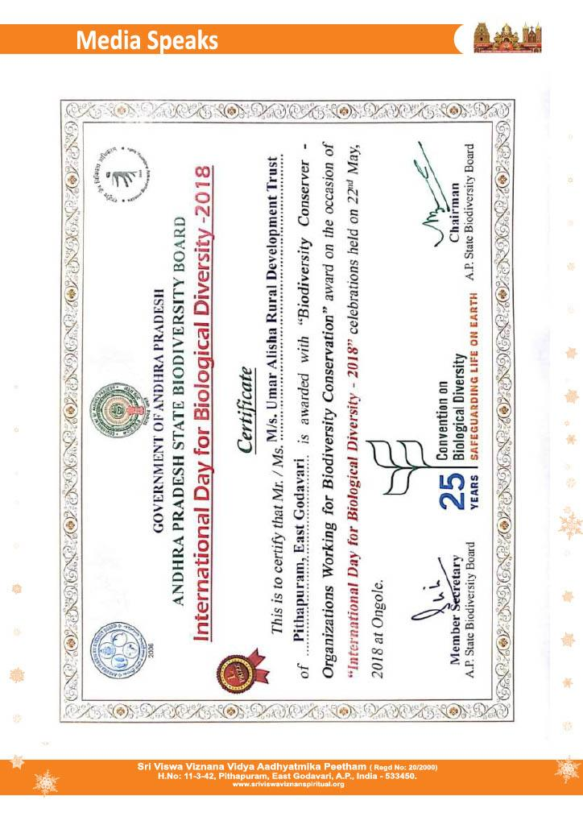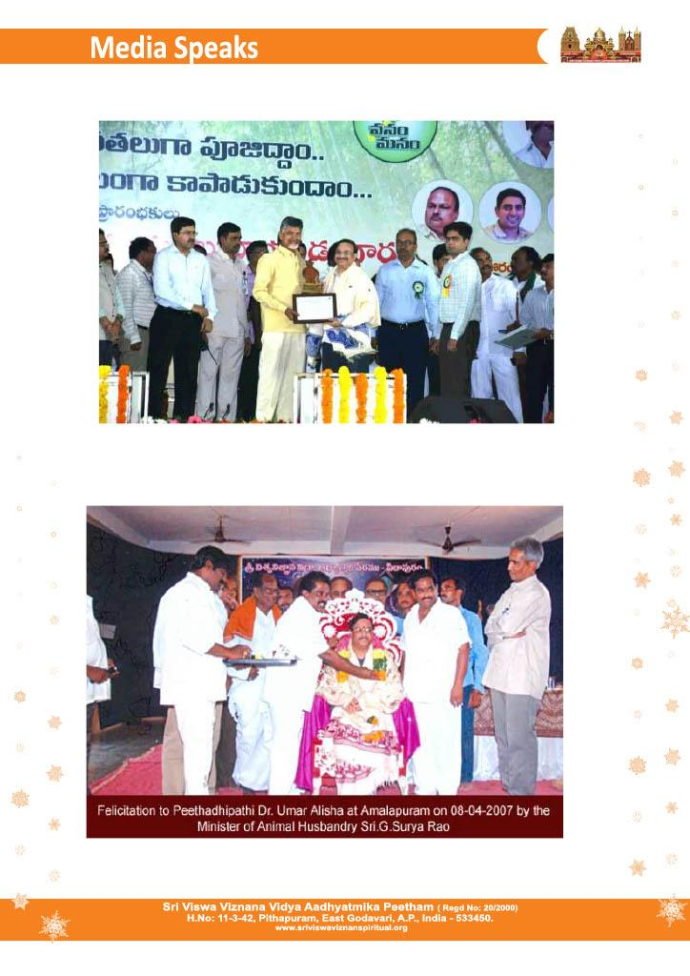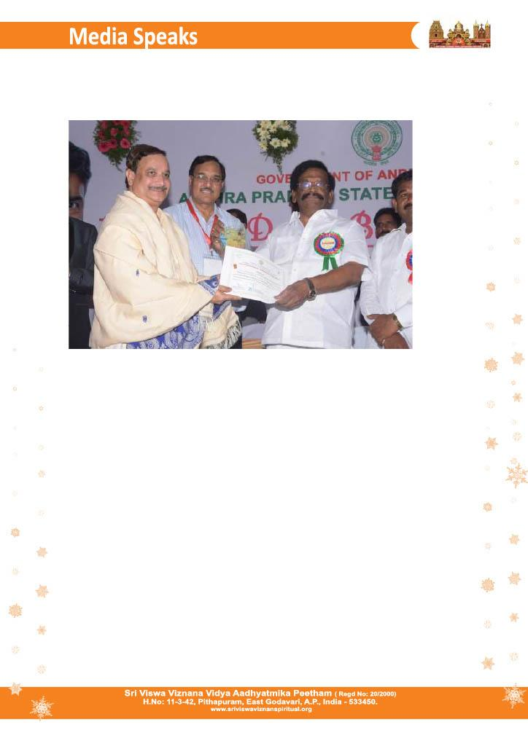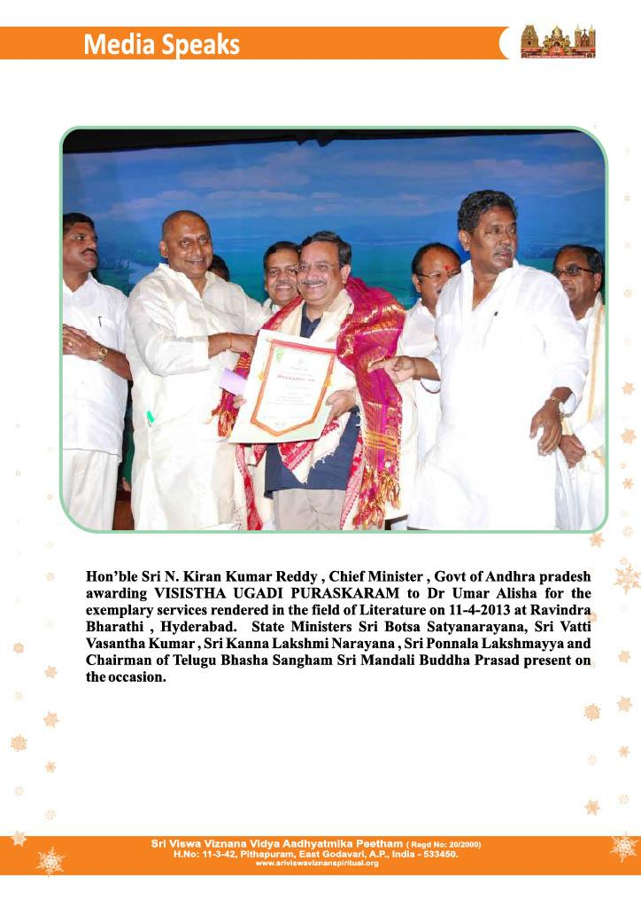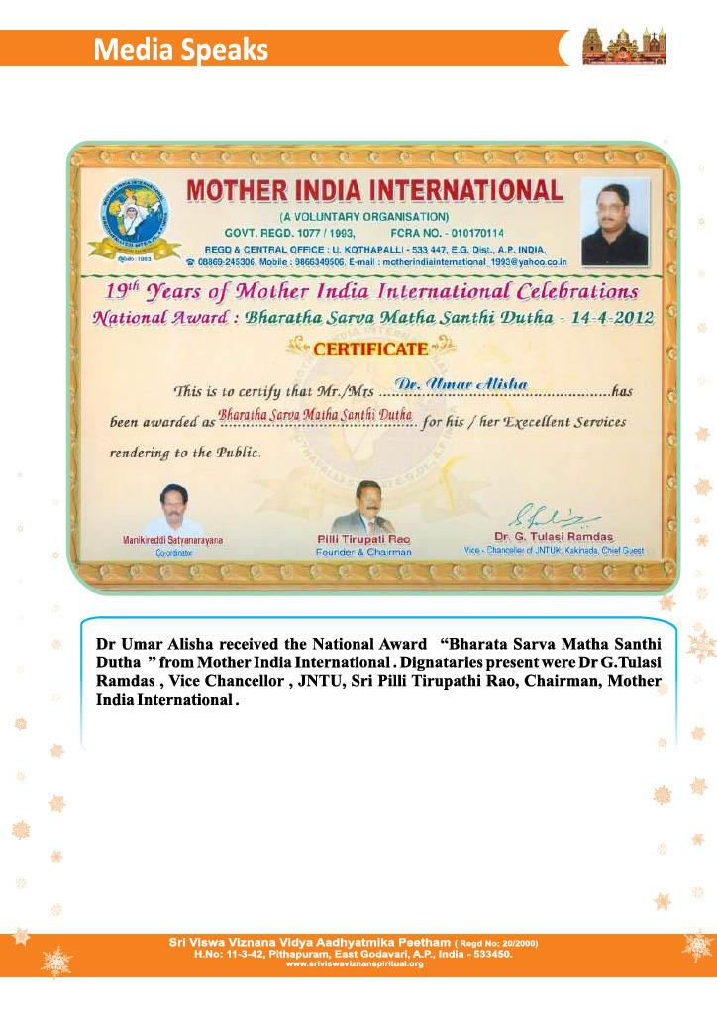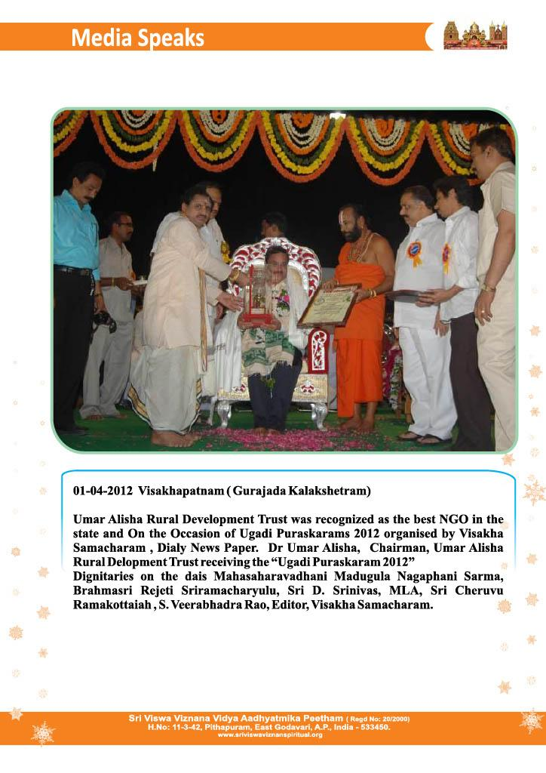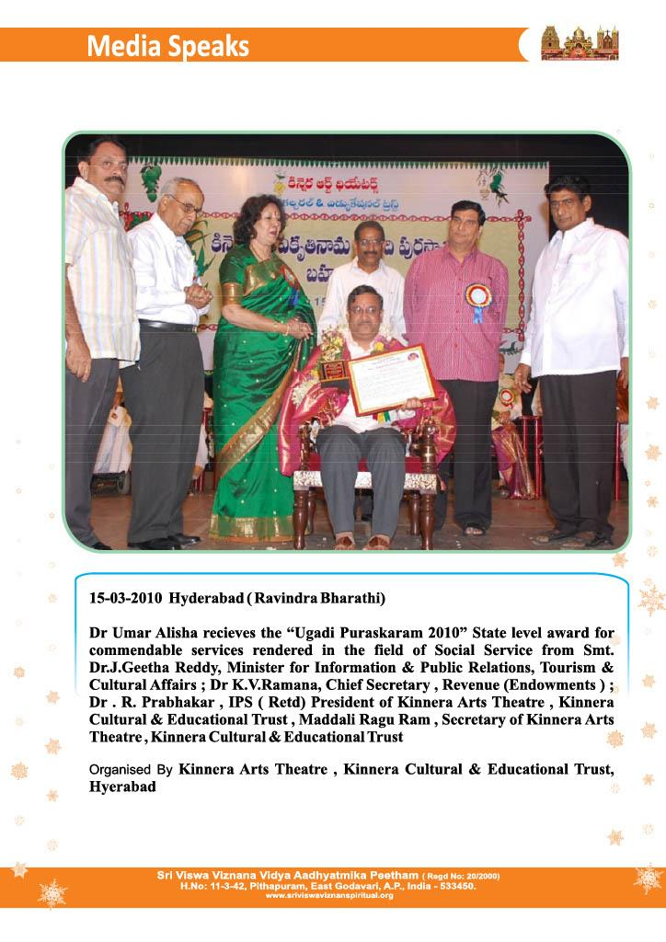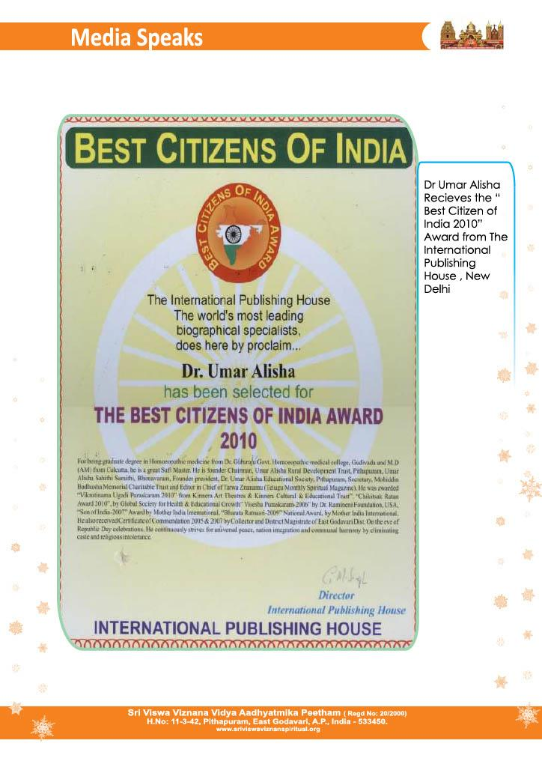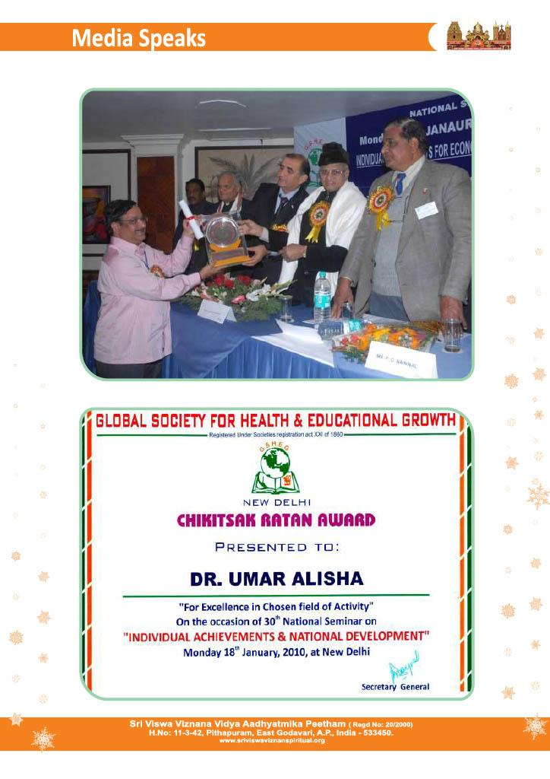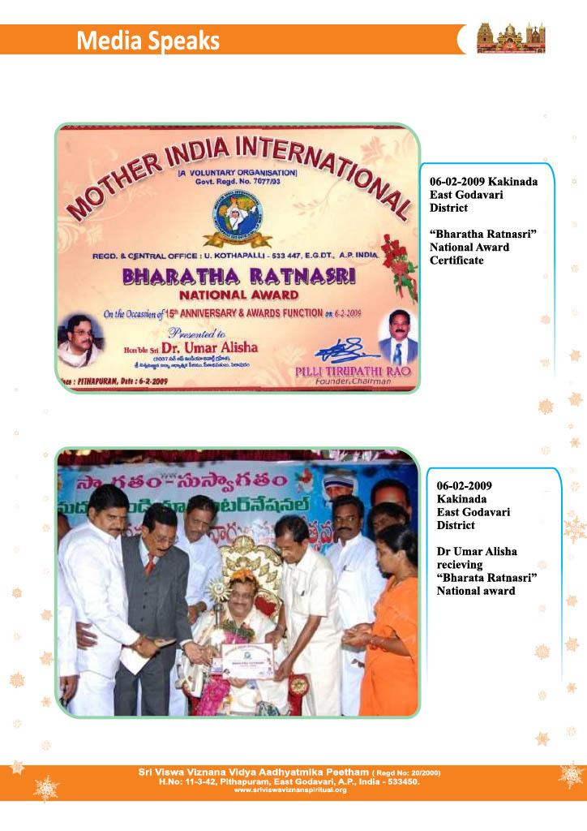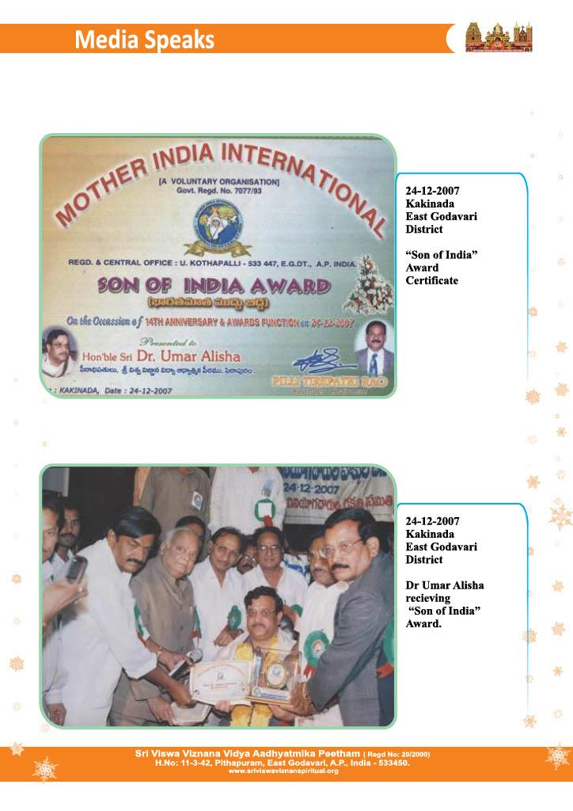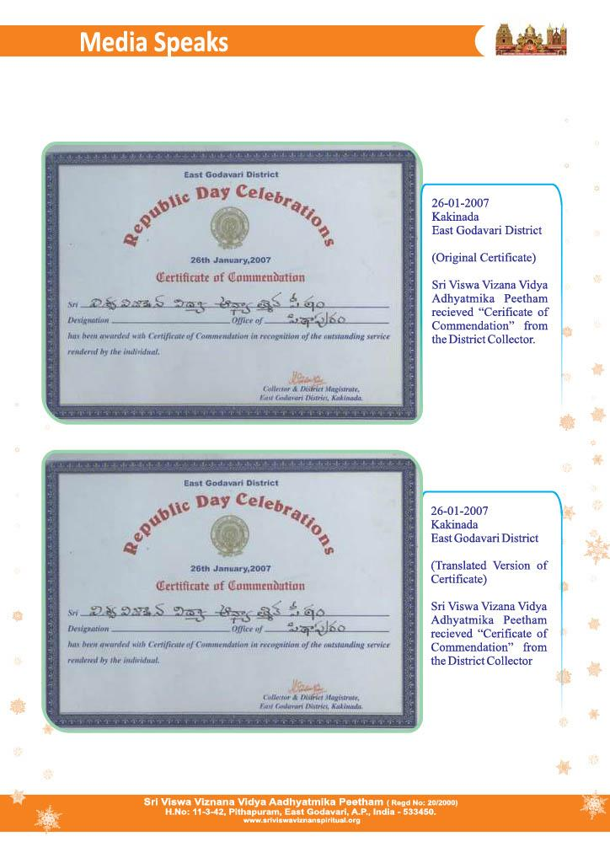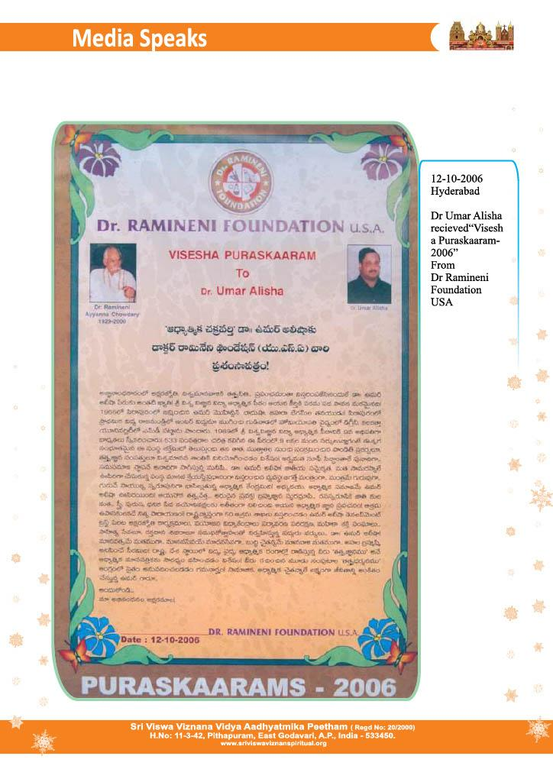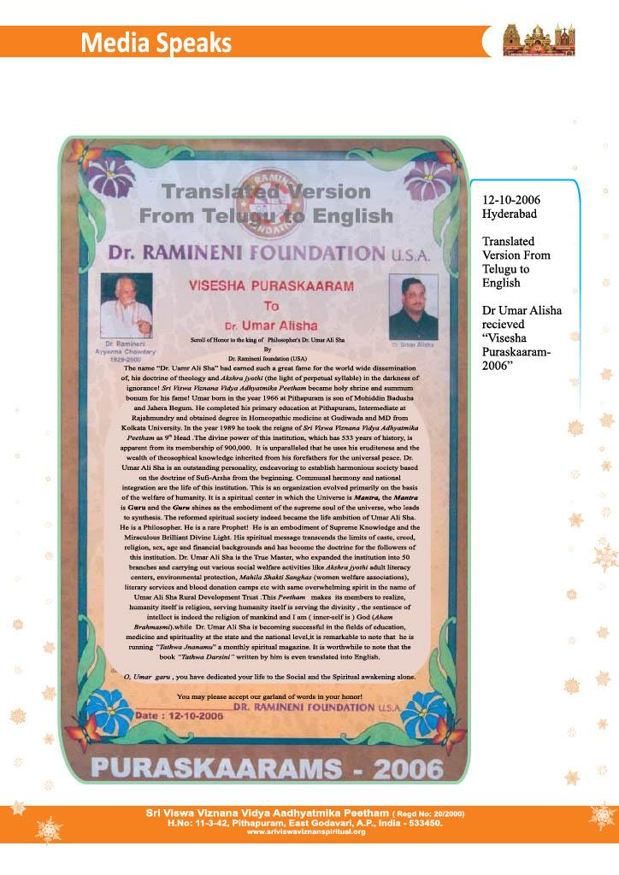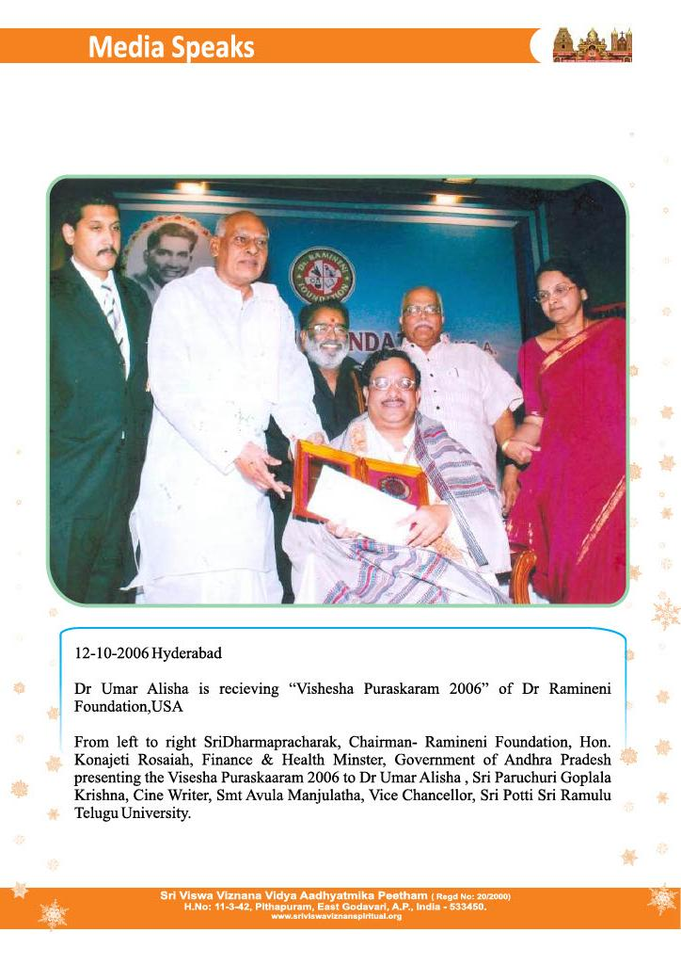
https://www.sriviswaviznanspiritual.org/05012020-sathguru-sri-dr-umar-alisha-receives-national-ganganadi-pushkara-puraskar-award-2020/

https://www.sriviswaviznanspiritual.org/drumaralishaprathibhabarathipursakar/

